
oooooooooooooklklklklkl

www.friendsofdalesrail.org

Newsletter June
2020
Contents
- Rod’s Ramblings
- Event Secretary’s report
- Thanks to Diane
- How to make a face covering from Margaret
- Alan’s questionnaire
- A little Ditty from our own poet laureate, Yvonne, with accompanying picture
- Coupe’s cookery corner
- Special mention to some members
- What’s app group
- YHA weekend September 2020 information
- Information on the October weekend 2020
Enclosures

- YHA booking form
- Membership renewal form
With thanks to Rod and the Hirsts again for their comical contributions.
A note from the editor
As I sit plodding away at this newsletter I thought that I should have been starting to pack for the holiday to Scotland. I am sure there are a number of you who are in that same boat or should it be up on the hills of Scotland? Let’s hope and pray that life will start to resume to some kind of normality soon and we can start walking as a group. Oh and doing some hugging!

It’s better to arrive 10 minutes late in life than 10 years early in the next.
Rod's Ramblings
I was going to write about the joys of walking in springtime. However the snowdrops, daffodils and tulips have been and gone and even the bluebells are beginning to fade. The lockdown continues albeit in a reduced form. We can now exercise all day if we want and even drive to a familiar locations and walk with one friend but still keeping 6ft apart. Further easing of restrictions are promised, provided we stick to the safeguarding rules to reduce and finally eliminate this deadly virus. So while group walking is not yet possible, your committee is going ahead with plans for the weekend holidays in September and October when we hope the situation will have improved.
I offer my heartfelt sympathy to those of you who have lost relatives and friends during this tragic period. I hope that the enduring friendship and support from fellow walkers will go some way to easing your pain.
Rod Macpherson Fall
(The Flying Scotsman!)

Event secretary’s report

The leaders Meeting took place on March 8th at Swadford Hall in Skipton in the afternoon. This was a new format. It was very well attended by Leaders Backups and members.. People brought their own lunches and refreshments were on hand. Thank you to Glennys and team for manning the kitchen. After a general discussion, Caroline from The St John’s Ambulance delivered a tailor made First Aid Course for walkers. Attendance was very full and the course very informative. Caroline was excellent and thorough. She had some first aid kits available for those who wished to purchase. The feedback has been very favourable both in terms of the venue and time as well as to the course delivered. It was felt a more central venue and a Sunday afternoon were much more convenient than a Monday evening in Leeds. We were extremely fortunate that this was arranged for the last weekend before lockdown.
Since then of course our walks programme has been suspended and our weekends away and summer break have been rearranged for next year. As I write train journeys are only for essential travel and the service reduced and group walking is out of the question. We can meet up with one person at a distance to walk and so we must continue to wait until this virus has subsided. I, for one have lost three friends in hospital to CV19 and am in shielding for at least 12 weeks. . We must be patient and wait for better times. I hope you are exploring your local area and discovering paths and ginnels you never knew existed. Please send your lockdown photos to Martyn for the AGM film show. I have seen many excellent photos from members posted online during this crisis. It will be interesting to see what you have all been up to. Even cities have much to surprise us. I for one have developed a 6.7 mile city walk mainly in woods and on tracks taking in two trigs. What have you been up to? Stay positive stay safe.

On a different note. I have had a phone call from Frank Reynolds, now in his late eighties and living in Leeds. He wishes to be remembered to everyone and sends his best wishes. He has some FoDR logo clothing items he wishes to donate to the Group and once I have them I will advertise them. I will bring them to the AGM in November.
Diane Taylor

Thank you Diane from all of us for organising a great first Aid course back in March.

Choose a job you love and you’ll never have to work a day in your life.

And now over to little” Margaret who has been doing her bit to keep safe and pass on her sewing skills! Photos included.

I have folded & put little bands in the ends so soft & comfy. Can be washed too. I know they will not be protection but may be a barrier to folk if I am carrying anything. Something for the AGM film show if we have one by then. Take care.

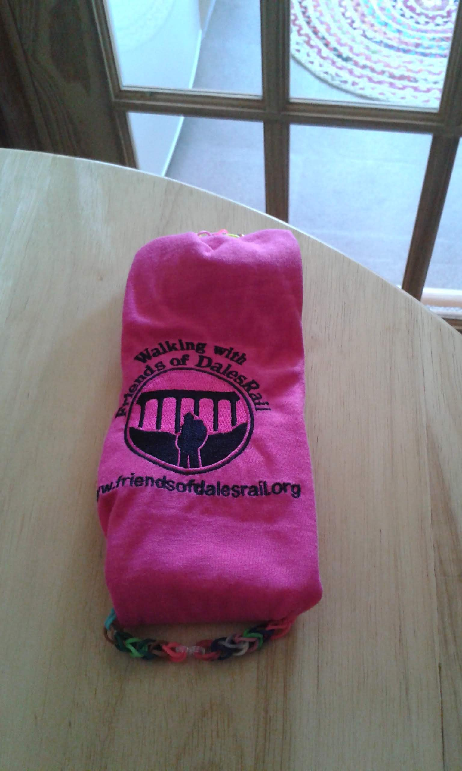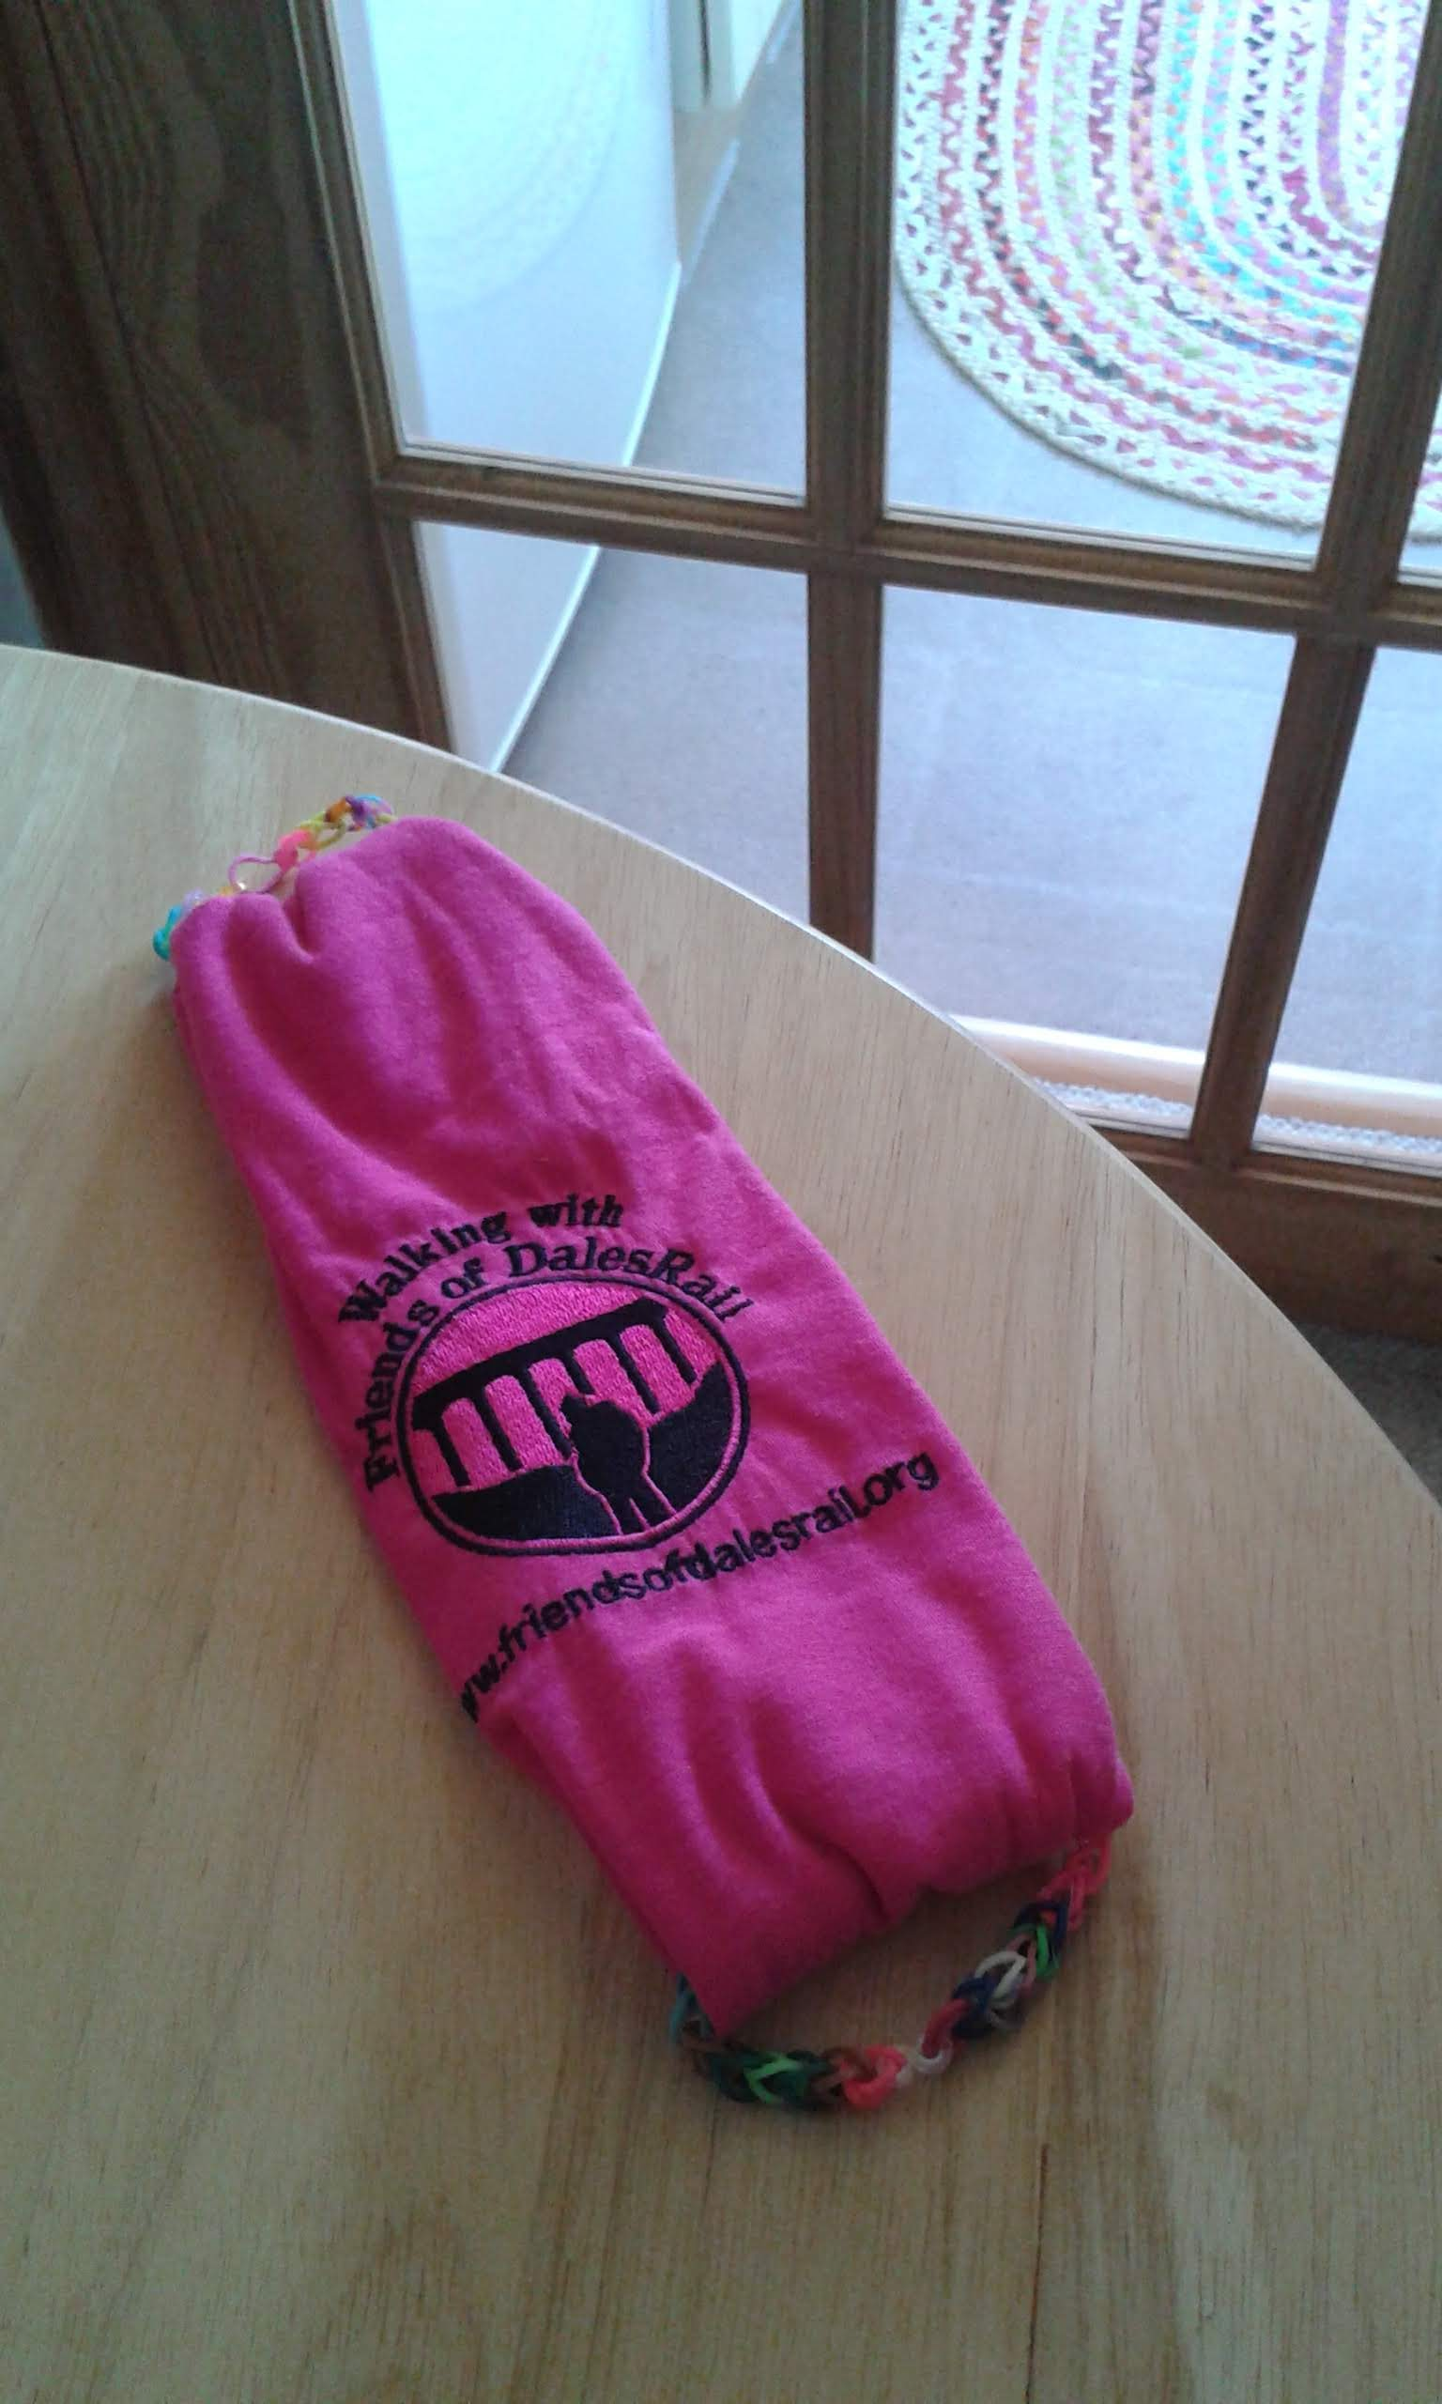

Behold the turtle, who makes progress only when he sticks his neck out.

And now over to Alan (this should have been included in the January newsletter so apologies Alan!)

Hello fellow members.
I have been co-opted to organise the weekend and summer walking breaks. It is necessary to begin the planning about a year in advance. The summer holiday for this year has been postponed to May 2021 to Kingussie so that is sorted..
I am looking forward to organising the holidays but I don’t want to be tied by what has been done in the past.
I would like to ask for your help, whether you have been on one of these holidays or not, whether you are an ‘easy’ walker or a ‘strenuous’ walker, whether you have access to a car or not, whether you are retired or working. Your input will help me to more closely provide what members want.

Please email me with your thoughts, and here are a few topics:-

Are the weekends / summer holidays good value, what should we aim for pricewise? Bear in mind that I don’t intend to encroach on the YHA weekends. The likelihood is that hotel quality/food etc. will vary with price. Should we alternate expensive and inexpensive ones?
Do you like to go to a new area each time or is it nice to go back to familiar places? How long should it be before going back to a successful destination?
If we chose a destination without say strenuous walking or easy walking would that be acceptable in order to visit a new area?
Should we offer a day trip to a place of interest nearby at a small supplement? On weekend and/or summer trips
Should the weekends offer an activity on the Friday afternoon?
Should the weekends be for 3 nights?
Should the booking form state the cost of extra nights at a special rate that you could book direct?
Should we look into a minibus taxi to get there and back to reduce the need for so many cars to be driven up? Would that be of interest for those without access to a car?
Comment on the walking please. Is a choice of 4 walks OK? How do you feel about walks not being reccied beforehand? How do you feel about leading or backing up a walk?
For the summer breaks in particular: - Are the coach pick-ups convenient? How long a journey is acceptable? Are the trips sufficiently flexible? Is a drying area at the hotel important? Do you like evening entertainment? Do dietary issues concern you?
Would you like a packed lunch included in the price?

Weekend venues in the last 10 years: -
Cumbria (Excluding the Lake District) 3
Lake District 8
Scotland 2
Whitby 1
North Wales 3
Northumberland 2
Cheltenham 1

Thank you Alan

Never judge a man until you have walked a mile in his shoes. After that, sod him, you’re a mile away and you’ve got his shoes.

A little Ditty by Yvonne P.

Locks 'n' Lockdown

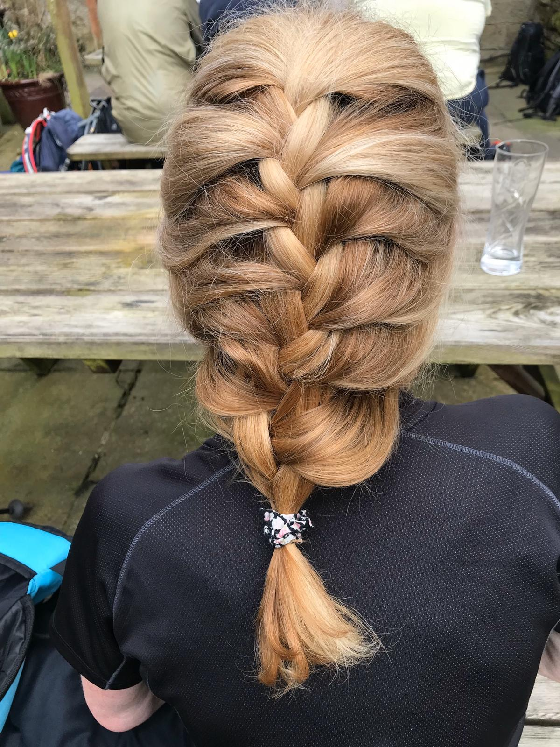

A golden blonde she is no more;
How dare she now walk out the door.
Her FoDR pals may whinge and whine
But God forbid they should see mine.
So now at last she looks her age:
No need to ask if she earns a wage.
Day after day she hides in the wood:
Attired more like Little Red Riding Hood.
If you should manage to catch her sat,
She'll be dreaming of her long lost plait.
The vacant look then begins to clear,
Thoughts returning of what's most dear:
Family, friends and nature too.
Her beaming face just says "thank you".

Coupe’s cookery corner

Something savoury.

Cheese and greens muffins

Ingredients

30g butter (I didn't measure, just did enough to fry the onions)
1/2 small red onion finely chopped
360g plain flour
2 1/2 tsp baking powder
1 tsp cayenne pepper
250g cheddar cheese, grated
220ml whole milk or semi skimmed
1 egg
130 g baby spinach leaves or other similar greens
Method
Preheat oven to 170c/325F/gas 3 and prepare 12 muffin cases.

Melt the butter over a medium heat and fry the onion until cooked. Set aside.
Put the flour, baking powder, cheese and cayenne in a large bowl.

In a separate bowl, mix the egg and milk together then slowly pour into the flour mixture and beat until all the ingredients are well mixed.

Stir in the onion and greens. Spoon into paper cases until 2/3 full and bake for 30-35 minutes, or until deep golden and the sponge bounces back when touched,
A skewer inserted in the centre should come out clean. Leave the muffins to cool slightly in the tray before turning out onto a wire cooling rack to cool completely.

And now a word about some of our members…….

During these very difficult times a couple of members/partners became ill with the virus. However they are now recovering well.
We wish Vanessa and Stuart, Anne Farrar’s husband all the best in recovering from this terrible illness. Keep safe and keep getting better.

Tony Fitzgerald carries on making really good progress and is spending lots of time on his allotments and growing lots of veg so keep it up Tony!

What’s app group
During these very difficult times a few of us have set up a What’s app group to keep in touch with one another.
It is a great group with many very funny and current jokes. There has been a suggestion that a 2nd group is set up to incorporate all members.
However there are some pitfalls. You will receive many messages per day and that your mobile no would be shared with everyone in the group. We would like to know what you think and then get in touch with Penny who will set it up if you want to join.

YHA weekend
Friday September 11th – Sunday September 13th

Langdale

I feel jinxed about this damn weekend! Originally I was going to stop organising it because numbers were low last year, but we had such a good time and quite a few regulars couldn’t come for exceptional reasons so I thought I’d give it a go. Then came the plague – we should have gone back to Eyam!

Anyway, the YHA is planning to open hostels again in August and by September we may have leave to stay in hotels etc so we are going ahead with the booking.

If they have been too optimistic and can’t open then, we will have our money refunded and I shall book it for the same time next year. I would like to encourage you to pay by bank transfer as that would make refunds much easier and less work for poor, beleaguered Martin!

I now see it as the glimmer of light on the horizon: a date to put in my diary, see real people and take my first summer holiday. I’ve been past the hostel on a walk earlier this year and it is in a delightful setting with access to all grades of walks and not too far to a bus stop.
At the moment car sharing is a no-no but that might have changed by then.

I encourage you to bite the bullet and book for either THE holiday of 2020 or guaranteed money back!

Penny Smith

On a Septic Tank Truck:
“Yesterday's Meals on Wheels.”

Future Walking Holidays from Sue

At this moment I cannot give you any information other than that already on the Friends of DalesRail web site

Weekend to Llanberis self drive 16th -19th October 2020
Until the government changes the lockdown guidelines for the hospitality sector, it is impossible to know if this weekend will be able to go ahead. We cannot make a contingency plan for a future date if it can’t go ahead in October.

The other 2 holidays that had to be cancelled due to Covid 19 have been rescheduled for 2021

Kingussie 7 nights 28th May – 4th June 2021
Dovedale self drive weekend 15th – 18th October 2021

The guest lists for these 2 holidays will stand unchanged.
As soon as I have information about Llanberris I will put it on the web site.

Sue

A SIGN IN A SHOE REPAIR STORE IN VANCOUVER, BC,
THAT READ:

We will heel you.
We will save your sole.
We will even dye for you.

